**Cyclistic Analysis**

Convert Casual Riders into annual members

horizontal line

# 

# Business Task

The question to answer is **How do Annual Members and casual riders use Cyclistic bikes differently?** Understanding the differences between annual members and casual riders would be a good start to then analyze and suggest further actions to the main goal that is to convert Casual riders into annual members

## Data Sources

We used the data from this bucket <https://divvy-tripdata.s3.amazonaws.com/index.html> and we are using all the csv files from 2017 until Sept. 2024

## Cleaning/Manipulation of the Data

We are using R so everything that is mentioned on this section will be part of the R file.

There were 3 different types of data with different column names or different column types, for example for all the csv files before the Q1 of 2020 the trip_id was a number but after Q1 of 2020 the company started to use a char that was composed by numbers and letters. So we convert all the rows before Q1 of 2020 to be a char in order to make data consistent.

There were some problems with the data like different column names and also there were rows were the end time was before the start time, so in order to make our data consistent we removed rows were end time was before start time, removed columns that won’t be used for the analysis (end_lng, end_lat, start_lat, start_lng, gender, birthyear, bikeid), we change some column names to make all the data from all csv files consistent:

* from_station_id -> start_station_id
* from_station_name -> start_station_name
* end_station_id -> end_station_id
* end_station_name -> end_station_name
* starttime -> start_time
* stoptime -> stop_time
* started_at -> start_time
* ended_at -> end_time
* member_casual -> usertype
* ride_id -> trip_id

The data after Q1 2020 didn’t include the trip duration column, and since we need it for our analysis we added it for all the rows after Q1 202 before merging with all the other data.

I noticed that there were rows which were empty on start_time so all those rows that were empty were removed.

After applying all those cleaning and manipulation of data, we bind all the data in one single dataframe on R to be ready to make the analysis.

## Analysis Summary

My Analysis was mostly using two variables:

* Trip duration
* UserType
* Start Date
* Aggregate Value: Number of trips

With those 3 variables in mind and the aggregate value that I got, I analyze how Casual riders differs from Members, we analyze the data in this 3 main comparisons:

1. Average Trip duration per UserType and week day
2. Average Trip duration per UserType and year
3. Average Trip duration per UserType, month and year
4. Number of trips per UserType and week day
5. Number of trips per UserType and year
6. Number of trips per UserType, month and year

## 

## 

## 

## 

## Visualizations & Key Findings

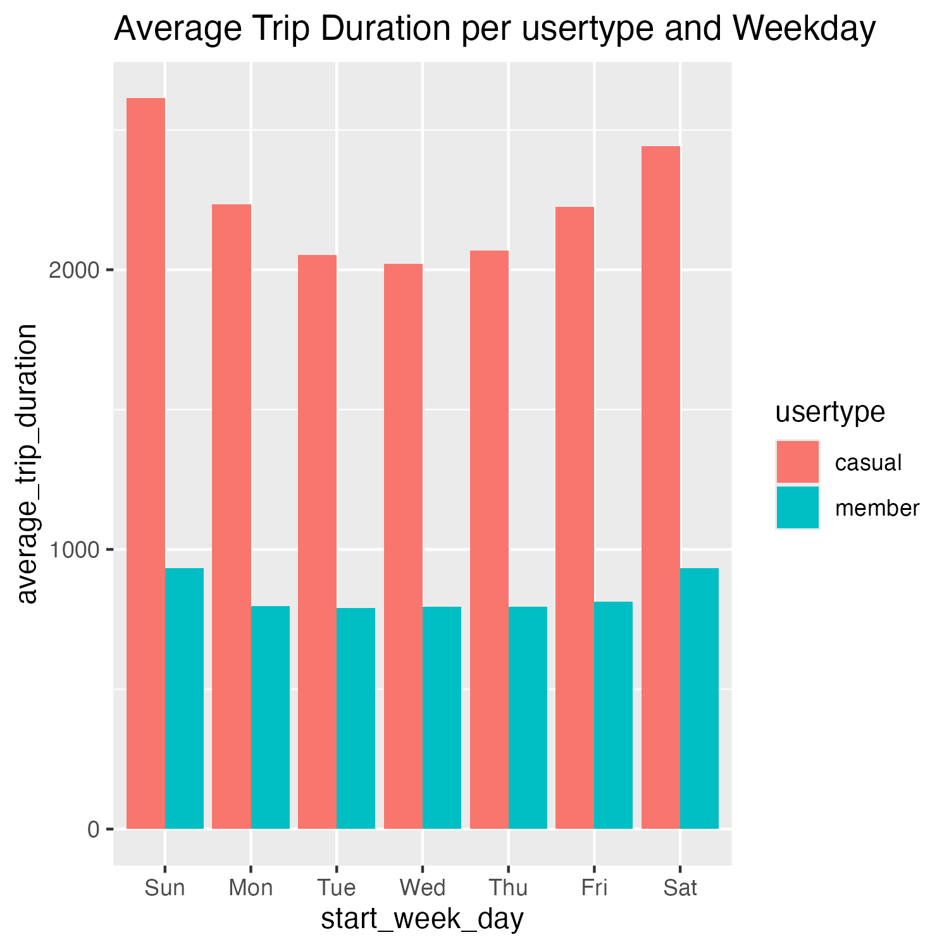

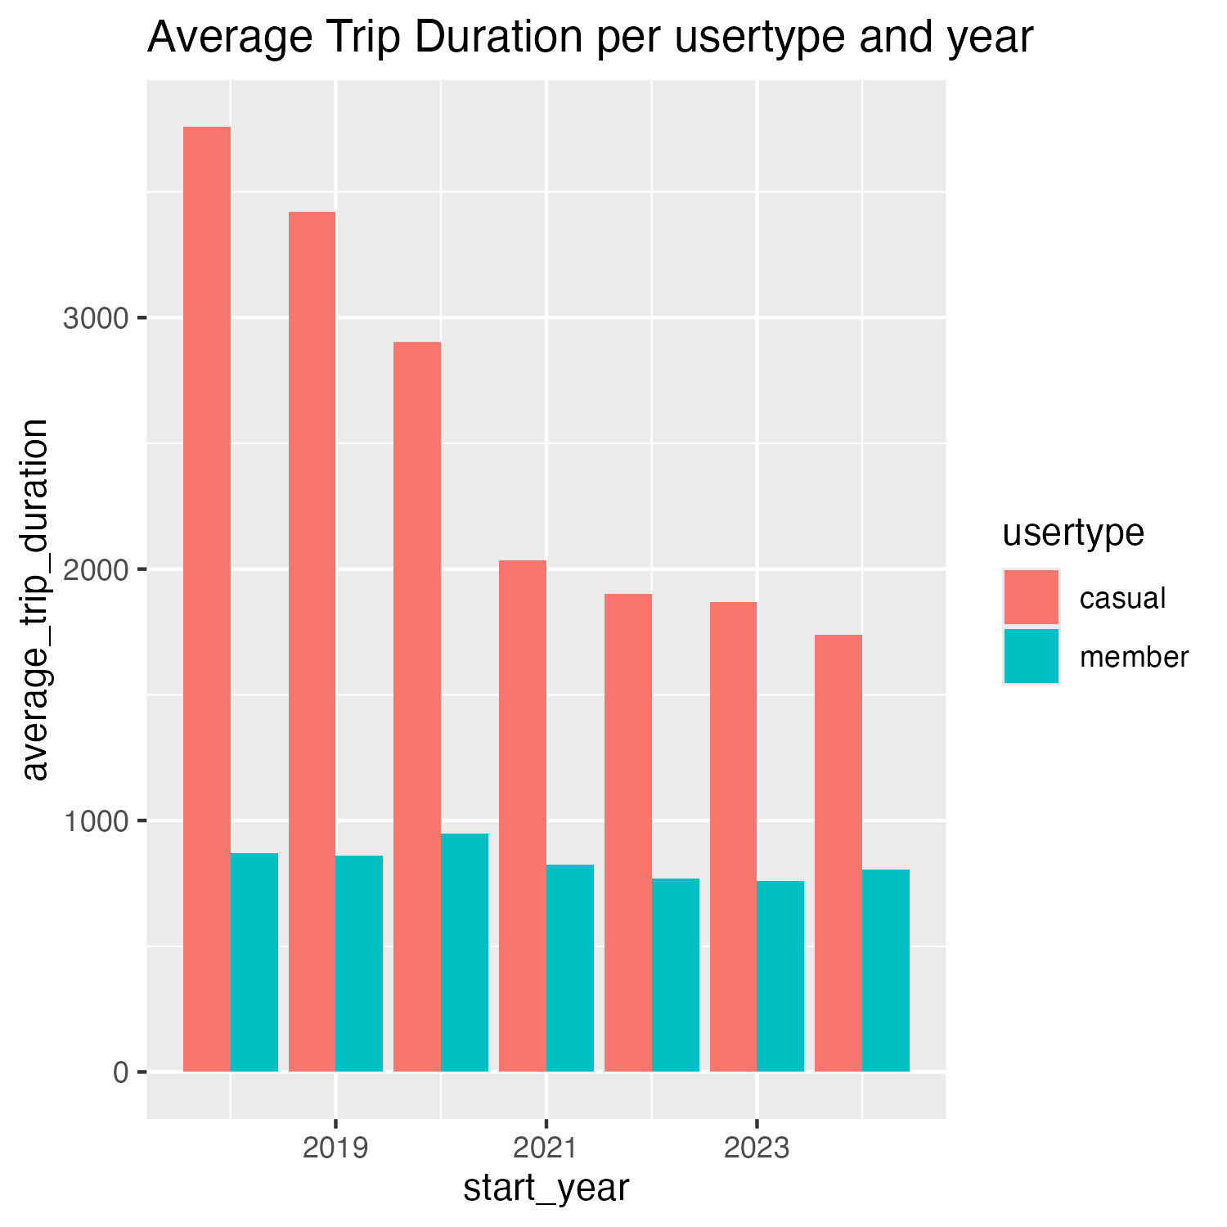

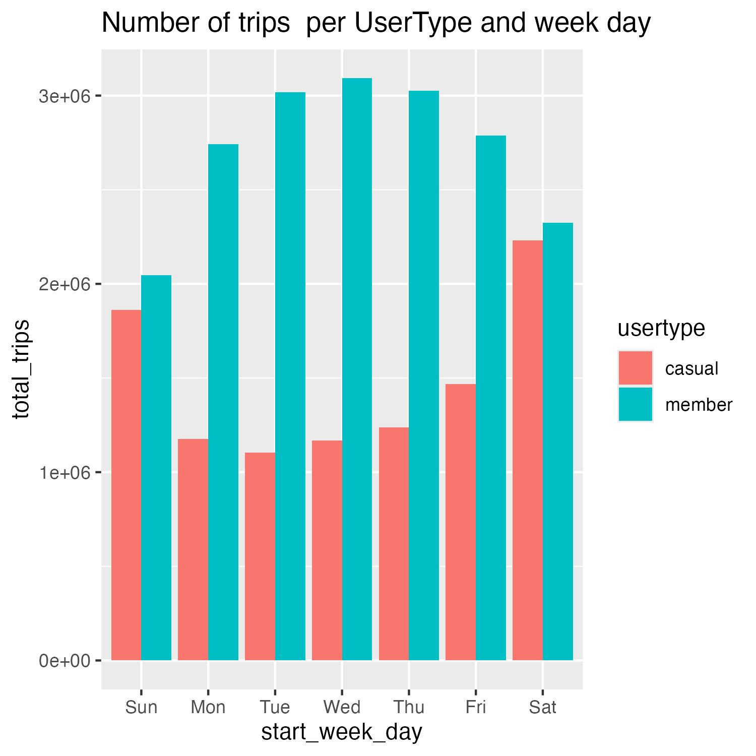

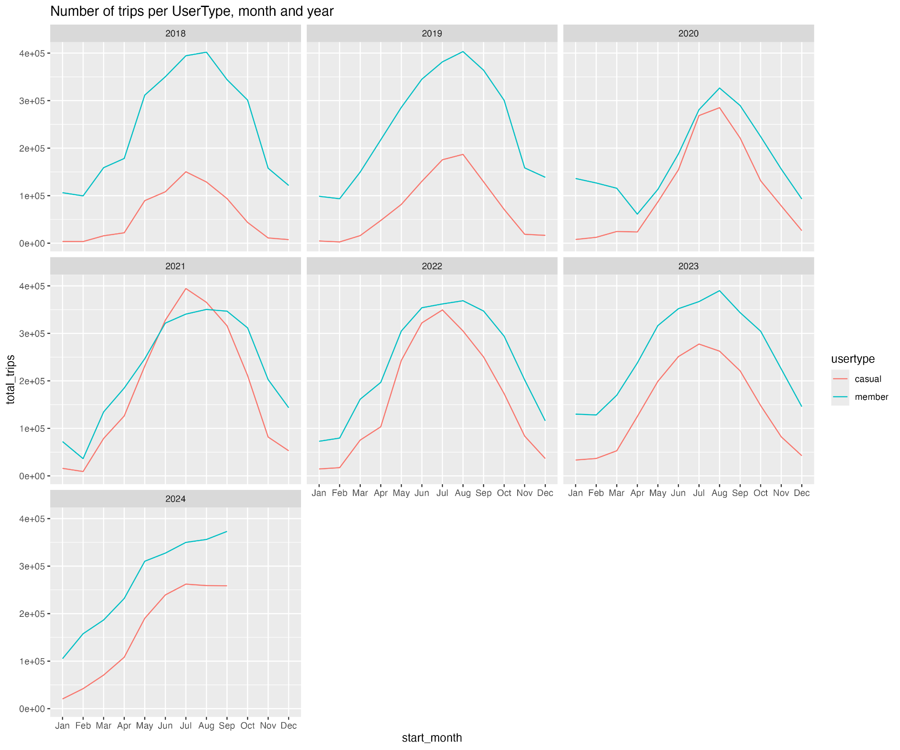

**Findings:**

* The Average Trip duration has a difference of more than 1000 seconds between casual and members riders through all the week
* The average trip duration has a slightly greater difference on weekends for both casual and members riders.
* The average trip duration keeps almost the same through all the years for members riders, but for casual the average has been decreasing through the last years
* Casual riders do more trips on weekends but members riders use it more on mid week (Tuesday, Wednesday and Thursday)
* Since 2022 Member riders has more trips than casual riders and also this amount of trips is greater during summer for both Casual and Members Riders

## Recommendations

1. The campaign could focus on how the casual riders can see Cyclistic as a transportation option in their work weeks in order to convert to an annual member
2. The campaign could give some time free for annual members to use the bikes after passing a certain threshold on the trip duration, this can incentivize casual members to convert into annual member
3. The campaign can give some gifts on weekends for annual members in order to promote more users to use Cyclistic on weekends